Learn

🚀 Step 1: Programming Fundamentals

1.Python Basics & Object-Oriented Programming (OOP)
- Learn Python syntax, data structures, and control flow.
- Understand Object-Oriented Programming (OOP) concepts like classes, inheritance, and polymorphism.

🛠 Step 2: Web Automation & Testing Frameworks

2️ Selenium – Web Automation
- Learn how to automate browser interactions using Selenium WebDriver.
- Work with locators (XPath, CSS), handling elements, and writing test scripts.

3️ Playwright – Modern Web Automation
- Faster alternative to Selenium with better support for headless browsers.
- Automate web apps with multiple browser support.

4️ BDD Framework – Behavior-Driven Development
- Learn BDD concepts and implement test cases using Cucumber or Behave.

5️ Pytest – Unit Testing Framework
- Write unit and functional tests using Pytest.
- Use fixtures, assertions, and parameterization for test efficiency.

📡 Step 3: API & Performance Testing

6️ Postman – API Testing Basics
- Send API requests (GET, POST, PUT, DELETE).
- Automate API workflows with Postman scripts.

7️ REST API Testing with Python
- Automate API validation using the requests module in Python.
- Implement API tests with Pytest.

8️ JMeter – Performance & Load Testing
- Load test APIs and web applications.
- Analyze response times and optimize system performance.

🔄 Step 4: CI/CD & DevOps Integration

9️ Jenkins – Automating Test Execution
- Set up CI/CD pipelines.
- Integrate Selenium, Pytest, and API tests into Jenkins jobs.

🔟 Docker – Running Tests in Containers
- Learn containerization concepts.
- Run automation tests inside Docker containers.

11 CI/CD – Continuous Integration & Deployment
- Automate test execution in DevOps workflows.
- Use Jenkins.

📊 Step 5: Monitoring & Logging

1️2 Prometheus – Monitoring & Alerting
- Collect and analyze system metrics.
- Create alerting rules for failures.

1️3Grafana – Visualizing Test Metrics
- Build dashboards for test execution data.
- Integrate with Prometheus & ELK stack.

1️4 Filebeat – Log Collection
- Ship logs from test runs to ELK.
- Set up log monitoring for debugging failures.

1️5 ELK Stack (Elasticsearch, Logstash, Kibana) – Centralized Logging
- Store and visualize automation logs.
- Filter and analyze test failures.

📡 Step 6: Message Queues & ETL Pipelines

1️6 Apache Kafka – Event Streaming & Messaging
- Work with real-time message queues.
- Implement test scenarios for distributed applications.

1️7 Zookeeper – Managing Distributed Systems
- Coordinate services in automation & Kafka environments.

1️8 ETL – Extract, Transform, Load (Data Processing)
- Automate data pipeline testing.
- Work with data ingestion and transformation scenarios.

📜 Step 7: python-Based Testing Frameworks (If Needed)

1️9JUnit – Unit Testing for python
- Write Java test cases using assertions and test runners.

2️0TestNG – Advanced Test Automation in Java
- Implement parallel testing, test annotations, and data-driven testing.

Addition:

SQL

AWS

Software testing and Manual testing.

What is Software Testing?
- It involves evaluating and verifying that software functions as intended.
- Ensures the software is fit for use.
- Aims to prevent defects and identify failures.

Importance of Software Testing
- Saves money by identifying issues early.
- Improves software quality.
- Enhances the development process.
- Ensures security and performance.

What is Objectives of Software Testing
- Prevents defects.
- Determines if the software is suitable for customers and it is ready to use by the end use.
- Identifies defects, bugs, and failures.
- Builds confidence in the software since we performed the testing we have confidence on our software.
- Reduces risks associated with software deployment.

What are some of the causes of software defects?
- Unclear requirements: When the requirements are not well-defined or documented, it can lead to misunderstandings and defects in the software.
- Unclear understanding about software purpose: If the development team does not fully grasp the purpose or goals of the software, it can result in features that do not meet user expectations.
- Miscommunication within the team: Poor communication among team members can lead to inconsistencies and errors in the development process.
- Mistakes by people during SDLC: Human errors during the Software Development Life Cycle (SDLC), such as coding mistakes or incorrect implementation of features, can introduce defects.
- Less skilled team: A team lacking the necessary skills or experience may produce lower-quality code, leading to more defects.
- External factors: Issues with third-party applications, libraries, or integration with other systems can also cause defects in the software.

What are different levels of Software Testing?
- Unit testing: This is the first level of testing, where individual components or units of the software are tested in isolation. The goal is to validate that each unit performs as expected.
- Integration testing: After unit testing, integration testing checks how different units or modules work together. This level ensures that combined parts of the software function correctly as a group.
- System testing: This level involves testing the complete and integrated software system to verify that it meets the specified requirements. It focuses on the overall behavior of the system.
- Acceptance testing: The final level of testing, where the software is tested to ensure it meets the business requirements and is ready for delivery to the end-users. This often includes user acceptance testing (UAT) to confirm the software is fit for use.

What is Unit Testing?
- Testing the smallest testable part of software: Unit testing focuses on the smallest components of the software, such as individual functions or methods.
- Done to validate that the lowest independent entity works as expected: The primary goal is to ensure that each unit of the software performs correctly according to its design.
- The smallest testable part is isolated and tested independently: Units are tested in isolation from the rest of the system to ensure that any issues are due to the unit itself and not external factors.
- STUBS and DRIVERS are used to replace missing components: Stubs simulate the behavior of missing components that the unit interacts with, while drivers are used to call the unit being tested and pass test data to it.

What is Integration Testing?
- Integration testing tests the interfaces between units: This level of testing checks how different units or modules interact with each other.
- The focus is to test the interactions with other integrated units/components/interfaces: The main objective is to identify issues that arise when units are combined, such as data format mismatches or communication errors.

What is System Testing?
- Testing the behavior of the whole system as per defined scope is known as system testing: This involves testing the complete and integrated software system to ensure it meets the specified requirements.
- System testing should investigate both functional and non-functional aspects of software: Functional testing checks that the system performs its intended functions, while non-functional testing evaluates aspects like performance, security, and usability.

What is Acceptance Testing?
- Acceptance testing is mostly done by customers/stakeholders in collaboration with the development team or independently: This testing phase involves end-users or stakeholders to validate the software against their requirements.
- Acceptance testing is done to check if software fits end user needs and establish confidence in the application: It ensures that the software meets the business needs and is ready for real-world use.
- It also helps to ensure that software meets any compliance and regulatory requirements: This is crucial for industries with strict regulatory standards, such as healthcare or finance.
- Acceptance testing helps to make GO/NO GO decision for releasing software for customer: Based on the results, stakeholders decide whether the software is ready for deployment or if further changes are needed.

What is the difference between Unit Testing and Integration Testing?
  - Unit testing is testing the smallest testable part of software.
  - Integration testing tests the interfaces between units.

What are different approaches of Integration Testing?
  - Big bang integration testing
  - Incremental integration testing
    - Top-down approach
    - Bottom-up approach
    - Functional incremental

What is big-bang Integration Testing?
  - All components or systems are integrated simultaneously, after which everything is tested as a whole.

What are advantages and disadvantages of big-bang Integration Testing?
  - Everything is finished before integration testing starts. So, STUBS and DRIVERS are not required.
  - Disadvantage is that it is difficult to trace cause of failures due to late integration.

What is Incremental Integration Testing?
  - All programs are integrated one by one, and testing is done after every step.

What are advantages and disadvantages of Incremental Integration Testing?
  - Advantage: Defects are found early, and it is easy to find the root cause for those defects.
  - Disadvantage: It is time-consuming because STUBS and DRIVERS are required.

What is the difference between Integration Testing and System Testing?
  - Integration Testing: The focus is to test the interactions with other integrated units/components/interfaces.
  - System Testing: Testing the behavior of the whole system as per the defined scope is known as system testing.

Difference between System Testing and Acceptance Testing:
  - System Testing: Involves testing the behavior of the entire system according to the defined scope.
  - Acceptance Testing: Conducted to ensure the software meets end-user needs and to establish confidence in the application.

What is Types of Acceptance Testing:
  - User acceptance testing
  - Operational acceptance testing
  - Contract acceptance testing
  - Compliance acceptance testing
  - Alpha testing
  - Beta testing

What is User Acceptance Testing (UAT)
  - Focuses on functionality and validates the system's fitness-for-use.
  - Requires heavy involvement from business users and stakeholders.
  - The UAT test environment should closely resemble the production environment.

Operational Acceptance Testing
  - Validates if the system meets operational requirements.
  - Includes tests such as:
    - Backup/restore testing
    - High availability and disaster recovery testing
    - Maintenance tasks testing
    - Periodic security vulnerability checks

Compliance Acceptance Testing:
  - Also known as regulation acceptance testing.
  - Conducted to ensure the system adheres to relevant regulations (e.g., government, legal, safety, medical).

Contract Acceptance Testing:
  - Performed against the acceptance criteria defined in a contract.
  - The acceptance criteria are formally established before the contract is signed.

Alpha Testing:
  - Conducted at the developer's site.
  - Involves exposing the software to people and environments outside the project team.
  - Aims to gather direct feedback from customers or potential customers to the developers.

Beta Testing:
  - Conducted after Alpha Testing.
  - Performed by potential or existing users, customers, and end-users at external sites without developer involvement.
  - Focuses on acquiring feedback from a broader market audience.

Difference between Alpha and Beta Testing:
  - Alpha Testing is done at the developer's site with some external involvement, while Beta Testing is conducted externally without developer involvement.
  - Alpha Testing aims for direct feedback from a limited audience, whereas Beta Testing seeks feedback from a larger, more diverse user base.

Difference between QA and QC:
  - QA (Quality Assurance):
    - Process-oriented.
    - Focuses on preventing quality issues.
    - Involves verification.
    - Proactive strategy.
    - Ex: when we are doing testing during the development cycle and addressing the issue – this will come under the QA
  - QC (Quality Control):
    - Product-oriented.
    - Focuses on identifying quality issues.
    - Involves validation.
    - Reactive strategy.
    - When we are doing the testing after the development cycle and addressing the issue – this will coms under the QC

QE (Quality Engineering):
  - A process that applies rigorous quality checks to each stage of the software development lifecycle.
  - Closely integrated with agile and DevOps processes.
  - Ex: john – is a Quality engineer and contributing in the agile method and DevOps phases.

Different types of software testing.
- Functional Testing:
  - Includes various types such as:
    - Unit Testing
    - Integration Testing
    - System Testing
    - Sanity Testing
    - Smoke Testing
    - Retesting
    - Regression Testing
- Non-functional Testing:
  - Includes types such as:
    - Performance Testing
    - Load Testing
    - Stress Testing
    - Volume Testing
    - Security Testing
- Testing the Structure or Architecture:
  - Refers to White Box Testing, which focuses on the internal structures or workings of an application.
- Testing Related to Changes:
  - Involves Retesting and Regression Testing to ensure that recent changes or fixes have not adversely affected existing functionality.

Difference between Manual Testing and Automation Testing:
  - Manual Testing: Involves executing test scripts manually without the use of any automated tools or scripts.
  - Automation Testing: Involves using automation tools or scripts to execute test steps and record outcomes.

Test Bed/Test Environment in Software Testing:
  - A setup that includes hardware (servers), software, network configurations, simulators, tools, and other necessary elements required to conduct software testing.

Test Case in Software Testing:
  - A detailed document that includes a set of input values, preconditions, test steps, expected results, and postconditions. It is developed to verify a specific software requirement.
  - Ex: it is set step and precondition, expected value to test the particular scenarios

Importance of Test Cases in Software Testing:
  - Provides a structured approach to testing specific conditions.
  - Helps in determining test coverage using a Requirements Traceability Matrix (RTM).
  - Assists other team members in understanding and executing tests.

What is Retesting?
- Confirmation testing or Re-testing comes into the picture when the test fails and a defect is logged against that test.
- Once the defect is fixed and a new build is obtained with the fixed defect, re-testing is done to make sure that the defect has been fixed and the test passes now.

What is Regression Testing?
- Regression testing is done to find the "unexpected side effects" of defect fixes or any code changes done in working code.
- The purpose of regression testing is to verify that any modifications in the software have not caused unintended side effects in the software.
- Regression tests are executed whenever the software changes, either due to a defect fix or the addition of new functionality.

main difference between retesting and sanity testing lies in their purpose and focus:
🔁 Retesting
- Purpose: To verify that a specific defect/bug has been fixed.
- Focus: Re-execution of failed test cases from a previous run.
- Planned: Yes, it's based on documented test cases.
- Scope: Very narrow, only targets the fixed issue.
- Example: If login failed due to a password bug, you retest login only after the fix.

🧠 Sanity Testing
- Purpose: To check that new functionality or a bug fix hasn't broken related features.
- Focus: Quick, high-level checks of a particular area to verify it's working logically.
- Planned: Often not formally planned or documented.
- Scope: Also narrow, but slightly broader than retesting.
- Example: If a new filter is added to search, sanity test might include searching, sorting, and viewing results to check related functions.

✅ Main Difference in One Line:
- Retesting checks if the bug is fixed.
- Sanity testing checks if the related area still works after a change.

What is the difference between retesting and regression testing?
Retesting and regression testing are both important parts of the software testing process, but they serve different purposes. Here’s a breakdown of the key differences:
1. Retesting
- Purpose: Performed to verify that a specific defect has been fixed.
- Focus: Tests only the defect that was reported and fixed.
- Test Cases: Uses the same test cases that originally identified the defect.
- Scope: Limited to the specific functionality where the defect was found.
- Execution: Performed on the same build where the defect was fixed.
- Automation: Usually done manually, as it's focused on specific defect verification.
- Example: If a login issue was found and fixed, retesting would involve running the login test again to ensure the fix works.
2. Regression Testing
- Purpose: Ensures that new changes (fixes, enhancements, or updates) haven’t negatively affected the existing functionality.
- Focus: Tests the overall stability of the application after changes.
- Test Cases: Uses a broader set of previously executed test cases to check for unintended side effects.
- Scope: Covers the entire application or specific modules affected by the change.
- Execution: Performed after fixes or changes have been made.
- Automation: Often automated to save time and effort.
- Example: After fixing the login issue, regression testing would check if related areas like user profile access, session management, and authentication flows still work as expected.

Why does the cost of fixing defects increase if the defect is found in later phases of SDLC?
- If the defect got introduced in development it will as less effect
- If it caught that in the testing rephrase it will affect more compare to the development
- If it caught that in the production rephrase it will effect more and again rework is need and cost will also increase in this phase.

What do you understand by the pesticide paradox principle and how to overcome it?
- If the same tests are repeated over and over again, eventually the same set of test cases will no longer find any new bugs. ¹

Is exhaustive testing possible?
- Testing everything (all combinations of inputs and preconditions) is not feasible except for trivial cases.

What are different Software Development approaches?
- Waterfall software development
- V-model
- Iterative Development approach
- Agile Software Development approaches (SCRUM / KANBAN / RAD / XP)

How is the V-Model different from the Waterfall Model?
- In the V-model, the involvement of the testing team was from the early phase of software development.
- The V-model came into the picture to overcome the limitations of the Waterfall model.
- Note: Waterfall Model: A sequential, linear approach

What is Agile?
- Agile is the ability to create and respond to change.
- Agile is a way of dealing with, and ultimately succeeding in, an uncertain and turbulent environment.
🚀 What is Agile?
Agile is a software development methodology that emphasizes:
- Iterative and incremental delivery
- Collaboration between teams and customers
- Flexibility to change
- Quick responses to feedback
🔄 Key Principles of Agile:
- Iterative & Incremental: Work is done in small cycles (iterations), usually 1–4 weeks, where each cycle adds usable features (increments).
- Customer Collaboration: Continuous communication with the client to ensure the product meets evolving needs.
- Responding to Change: Agile embraces changes even late in development.
- Working Software Over Documentation: Focus is on delivering functional software frequently.
- Cross-functional Teams: Developers, testers, and other roles work closely together.

What is Agile Software Development?
- Agile software development is an umbrella term for Agile Software Development frameworks like SCRUM, KANBAN, XP, etc.
- Any Agile software development framework embraces the values and principles defined in the Manifesto for Agile Software Development.

What is SCRUM?
- SCRUM is one of the Agile Software Development Frameworks.
- SCRUM encourages teams to learn through experiences.
- Self-organize while working on a problem.
- Continuously improve.

Diff btw Test Plan and Test Strategy

Feature | Test Plan | Test Strategy
Definition | A project-specific document detailing the testing approach, scope, and schedule | A high-level document outlining the general testing principles and methodology
Scope | Narrow (specific to a project) | Broad (applies to multiple projects or the whole organization)
Created By | Test Manager or QA Lead | QA Director or Senior Management
Focus | Defines project-specific details (resources, timelines, scope) | Defines overall testing guidelines and principles
Changes? | Can change frequently per project | Rarely changes (stable, long-term guidelines)
Level | Low-level document | High-level document

Can you explain the Test Process used in your current project?
- Test Planning
- Test Analysis
- Test Design
- Test Execution
- Evaluating exit criteria
- Test Reporting
- Test Closure

What do you understand by Requirement Analysis?
- Requirement analysis involves defining, analyzing, validating, and aligning stakeholders.
- You should check the requirement factors like: Atomic, Uniquely identified, Complete, Consistent and unambiguous, Traceable, Prioritized, Testable.

What is Test Planning?
- Test planning is the activity in SDLC where the lead QA or manager plans the testing for the relevant scope and prepares the test plan document.

How do you approach Test Case Development?
- Analyze requirements
- Prepare test scenarios by applying different test design techniques
- Elaborate test scenarios into test cases

What do you do in test execution?
- Testers start executing test cases assigned to them in the test environment.

What is entry and exit criteria in software testing?
- The entry criteria help you to decide when can you start the testing for a particular testing phase.
- The exit criteria help you decide when to stop the testing for a particular phase.
- The Exit Criteria from one stage forms part of the Entry Criteria into the next testing phase.

What is DoR (Definition of Ready) and DoD (Definition of Done)?
- DoR (Definition of Ready): A checklist of what needs to be done to a product backlog item before the team can start implementing it in the next sprint.
- DoD (Definition of Done): A checklist that defines when a product backlog item is considered "Done".

What do you understand by test closure?
- Collect data from completed test activities and prepare a consolidated report. Major tasks in test closure activities are:
  - Check which planned deliverables have been delivered (Test strategy/plans, test cases, etc.). All incident reports have been resolved (Fixed/deferred).
  - Finalize and archive Testware for later use (Test cases, test scripts, test data, or any other test artifacts).

White Box Testing (Clear Box Testing)
- Definition: White Box Testing, also known as Clear Box Testing or Glass Box Testing, is a type of software testing where the tester has full visibility into the internal workings of the application. This includes the source code, logic, and design.
- Approach:
  - The tester designs test cases based on knowledge of the code structure and algorithms.
  - Focus is on internal processes, logic flows, code paths, conditions, and branches.
  - It requires deep knowledge of the programming languages, frameworks, and logic used in the development.
- Purpose: White Box Testing is used to verify the internal operations of the system and ensure that it works as intended from the inside out.
- Types of White Box Testing:
  - Unit Testing: Testing individual functions or methods.
  - Integration Testing: Testing interactions between integrated components or systems.
  - Code Coverage: Ensuring that the code is fully covered by tests (e.g., testing all possible branches and paths).
  - Path Testing: Ensuring all logical paths in the program are tested.
- Example: In White Box Testing, a tester might check if every conditional branch (like if and else) in a function is executed to ensure proper decision-making in the code.

Black Box Testing (Functional Testing)
- Definition: Black Box Testing focuses on testing the software's functionality from the end user's perspective. In this method, the tester does not need to know the internal workings, code, or logic of the application.
- Approach:
  - The tester only interacts with the software through its user interface or APIs, providing inputs and observing the outputs.
  - Focus is on validating that the system meets the specified requirements and behaves as expected from the user's point of view.
  - Testers are concerned with inputs, outputs, and the software's behavior under various conditions.
- Purpose: Black Box Testing aims to ensure that the software behaves correctly and meets the user's needs without the tester knowing the internal code details.
- Types of Black Box Testing:
  - Functional Testing: Testing specific functions or features to make sure they work as expected.
  - System Testing: Testing the whole system for compliance with requirements.
  - Acceptance Testing: Ensuring the software meets the client's needs and is ready for deployment.
  - Usability Testing: Ensuring the software is user-friendly and intuitive.
- Example: In Black Box Testing, a tester might input different combinations of values into a login form to check if it correctly accepts valid credentials and rejects invalid ones, but the tester doesn't need to know how the login logic works internally.

What is Grey Box Testing?
- Grey Box testing is a combination of both White Box Testing and Black Box Testing methods.
- It is a software testing technique to test a software with partial knowledge of the internal structure of the application.

Stages of the Defect Life Cycle
New → A tester finds a defect and logs it in the defect tracking system.
Assigned → The defect is assigned to a developer for analysis and fixing.
Open → The developer starts working on fixing the defect.
Fixed → The developer fixes the defect and marks it as "Fixed."
Retest → The tester retests the defect to verify the fix.
Verified → If the fix works, the tester marks the defect as "Verified."
Closed → If everything works fine, the defect is closed.

Bug vs Defect – Main Difference:
✅ Key Points:
- A defect is any mistake or issue introduced in the design, code, or requirement.
- A bug is what we often observe during testing or use — it's the result or manifestation of a defect.
- In many teams, these words are used as synonyms, especially in casual conversation, but technically:
Defect is the cause → Bug is the symptom.

🧠 Example:
- A developer writes a function that calculates tax but forgets to handle a certain edge case.
→ That mistake in logic is a defect.
- During testing, the app crashes when that edge case is tested.
→ That crash is a bug.

Sanity Testing 🔍
Sanity Testing is a type of software testing performed to verify that a specific functionality or bug fix works correctly without conducting a full regression test. It is a quick, focused check to ensure that recent changes haven't introduced critical issues.

Key Features of Sanity Testing
✅ Purpose → To check if a specific feature or bug fix works as expected.
✅ Scope → Narrow, focusing only on the modified parts of the application.
✅ Execution → Usually done manually and quickly.
✅ When to Perform → After a bug fix, small code changes, or minor enhancements.
✅ Subset of → Regression Testing.
Sanity Testing vs. Smoke Testing
Feature | Sanity Testing 🔍 | Smoke Testing 🔥
Purpose | Verify specific fixes/features | Check if the build is stable for testing
Scope | Narrow (focused on recent changes) | Broad (covering major functionalities)
Performed When | After bug fixes or minor updates | After receiving a new software build
Test Coverage | Limited to the affected area | Covers core functionalities
Example | Checking if a fixed login issue works | Checking if login, homepage, and navigation work

In Summary
- Sanity Testing = Quick check after a fix.
- Smoke Testing = High-level check to ensure stability before detailed testing.

Difference Between Sanity Testing & Regression Testing
Sanity Testing and Regression Testing are both used after code changes, but they serve different purposes. Here's a clear comparison:

1. Sanity Testing 🔍
✅ Purpose → To verify that a specific bug fix or new feature works as expected.
✅ Scope → Very limited; focuses only on the changed functionality.
✅ When to Perform → After bug fixes or minor enhancements.
✅ Test Cases → Not pre-written; ad-hoc testing based on recent changes.
✅ Execution → Typically manual and quick.
✅ Subset of → Regression Testing.
📌 Example:
A tester verifies that a fixed "checkout button not working" issue is now functioning but does not test other areas like search or login.

2. Regression Testing 🔄
✅ Purpose → To ensure that new changes have not affected existing functionality.
✅ Scope → Broad; covers multiple modules and features.
✅ When to Perform → After bug fixes, new features, or code updates.
✅ Test Cases → Uses predefined test cases from a regression test suite.
✅ Execution → Often automated for efficiency.
✅ Includes → Sanity Testing (in some cases).
📌 Example:
After fixing the checkout button, testers also check login, product search, and payment processing to ensure nothing else broke due to the fix.

Key Differences at a Glance
Feature | Sanity Testing 🔍 | Regression Testing 🔄
Objective | Verify specific bug fixes or small changes | Ensure new changes don’t break existing features
Scope | Narrow (only the affected module) | Broad (entire application or related modules)
Performed When | After minor updates or bug fixes | After major code changes or releases
Test Cases | No predefined test cases; quick checks | Uses predefined test cases
Execution | Mostly manual | Often automated
Subset of | Regression Testing | Independent testing phase

In Summary
- Sanity Testing = Quick, focused check after a fix.
- Regression Testing = Broad, thorough check after any change.

What to Do If a Developer Says "It's Not a Defect"? 🤔
When a developer rejects a defect, follow these steps to clarify, justify, and resolve the situation professionally:
Reproduce the Defect 🔄
✅ Re-test the issue to ensure it actually exists.
✅ Check if it is happening consistently across different scenarios.
✅ Capture relevant screenshots, logs, or screen recordings as proof.
📌 Example: If a "Submit" button isn’t working, record a video showing that clicking the button does nothing.
Check Requirements & Specifications 📜
✅ Compare the issue with functional requirements, user stories, or design documents.
✅ If the expected behavior is clearly mentioned, reference the documentation.
📌 Example: If the requirement says "Clicking the checkout button should navigate to the payment page," but it doesn’t, you have valid proof.
Discuss with the Developer 🤝
✅ Arrange a quick discussion to understand their point of view.
✅ Explain why you believe it’s a defect using evidence and documentation.
✅ Stay professional and open to discussion.
📌 Example: “According to the requirement document, the system should allow users to reset passwords via email, but this functionality isn’t working. Here’s the proof.”
Final Outcome:
✔ If proven as a valid defect, the developer will fix it.
❌ If it’s not a defect, update the report with the explanation and close it.

What is boundary value analysis, and why is it important in testing?
Answer: Boundary value analysis is a testing technique where test cases are designed to focus on the boundaries of input values, rather than the middle. The idea is that errors often occur at the boundaries of input ranges. For example, if a system accepts input values between 1 and 100, boundary values would be 0, 1, 100, and 101.

SDET (Software Development Engineer in Test) – Overview
SDET (Software Development Engineer in Test) is a hybrid role that combines software development and software testing skills. SDETs are responsible for writing test automation scripts, developing testing frameworks, and ensuring the overall quality of a software product.
Key Responsibilities of an SDET
- Test Automation – Writing automated test scripts using tools like Selenium, Cypress, or Playwright.
- Developing Test Frameworks – Creating reusable test frameworks for efficient testing.
- Performance & Security Testing – Ensuring software is optimized and secure.
- CI/CD Integration – Automating tests in Continuous Integration/Continuous Deployment (CI/CD) pipelines.
- Code Review & Debugging – Reviewing code for testability and debugging issues.
- Collaboration with Developers – Working closely with developers to implement test-driven development (TDD) and behavior-driven development (BDD).
Skills Required for an SDET
- Programming Languages – Java, Python, JavaScript, C#, etc.
- Test Automation Tools – Selenium, TestNG, JUnit, Appium, Cypress.
- CI/CD & DevOps – Jenkins, GitHub Actions, Docker, Kubernetes.
- Database Testing – SQL, NoSQL databases.
- API Testing – Postman, RestAssured.
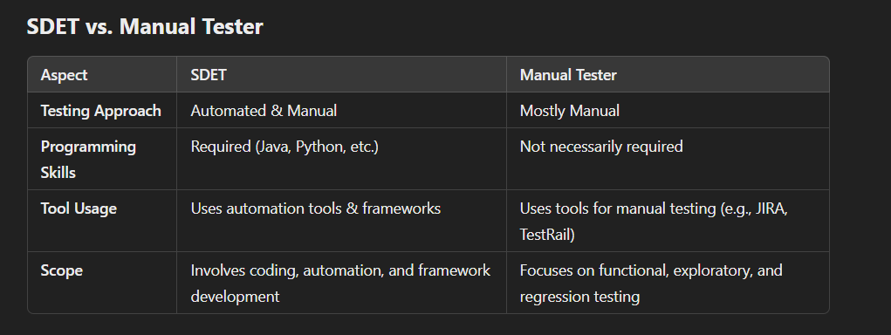

STLC (Software Testing Life Cycle) vs. SDLC (Software Development Life Cycle)
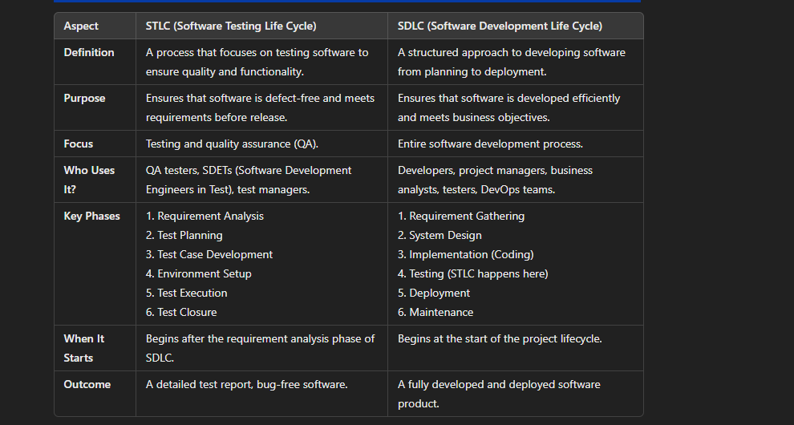
Key Difference
- STLC is a part of SDLC. While SDLC covers the entire software development process, STLC specifically focuses on testing.
- STLC is only about testing activities, whereas SDLC involves development, testing, deployment, and maintenance.

Automation testing

What kind of difficulties have you noticed during testing?
1. Unclear or Changing Requirements
- Often, requirements are ambiguous or keep evolving, making it hard to create stable test cases.
- Solution: Regular discussions with stakeholders and maintaining a well-updated test plan.
2. Environment Issues
- Test environments may not match production, leading to inconsistent results.
- Downtime or misconfigurations in test environments can delay testing.
- Solution: Ensure environment setup documentation and automate environment validation.
3. Test Data Challenges
- Lack of real or sufficient test data can impact test coverage.
- Data privacy constraints may limit access to real-world data.
- Solution: Use data-masking techniques and create synthetic test data where needed.
4. Flaky or Unstable Tests
- Automated tests failing intermittently due to timing issues or dependencies.
- Solution: Debug logs, retry mechanisms, and improving test stability using proper waits.
5. Tight Deadlines & Resource Constraints
- Limited time to execute full regression testing.
- Lack of dedicated test environments or devices.
- Solution: Prioritize critical test cases and use risk-based testing.
6. Compatibility Issues
- Applications behaving differently across browsers, OS, or devices.
- Solution: Perform cross-browser and cross-platform testing using tools like Selenium Grid, BrowserStack.
7. Defect Reproducibility
- Some bugs are hard to reproduce due to inconsistent behavior.
- Solution: Capture logs, screenshots, and use session recorders like Charles Proxy or Wireshark.
8. Communication Gaps
- Misalignment between developers, testers, and business teams leading to misunderstandings.
- Solution: Clear documentation, regular meetings, and collaboration tools like JIRA, Confluence.

How do you ensure comprehensive test coverage for a new feature?
Comprehensive test coverage can be ensured by performing the following steps:
- Requirement Analysis: Start by analyzing the requirements thoroughly to understand the feature’s functionality.
- Test Case Design: Create test cases that cover all possible use cases, including edge cases. This should include both positive and negative test scenarios.
- Test Case Review: Conduct reviews with stakeholders or peers to ensure nothing is missed.
- Automation: Use automated tests where applicable to ensure broad and repeated coverage.
- Traceability Matrix: Use a requirement traceability matrix to map test cases to requirements.
- Exploratory Testing: Conduct exploratory testing to identify areas not covered by predefined test cases.

How do you decide when to automate a test case and when to test manually?
- Automate repetitive, high-risk, and regression test cases (e.g., API validation, database checks).
- Manual testing is better for exploratory, UI design validation, and one-time test scenarios.

What are some challenges you’ve faced in test automation, and how did you overcome them?
- Challenge: Dynamic elements in web automation.
  - Solution: Used XPath strategies, WebDriverWait, and attribute-based locators.
- Challenge: Handling flaky tests.
  - Solution: Implemented retry mechanisms and improved test data consistency.

Can you explain how you use pytest for automation?
- I use pytest for:
  - Parameterized testing (@pytest.mark.parametrize)
  - Fixtures for setup/teardown (@pytest.fixture)
  - Parallel execution (pytest-xdist)
  - Generating reports (pytest-html)

How do you handle dynamic elements in Selenium or API responses in automated testing?
- For Selenium:
  - Use WebDriverWait with expected_conditions.
  - Find elements by stable attributes instead of dynamic IDs.
- For API responses:
  - Use JSON path or regex to extract required fields.

What are fixtures in pytest, and how do they improve test execution?
- Fixtures are reusable setup and teardown methods. Example:
python
CopyEdit
@pytest.fixture
def db_connection():
conn = Database.connect()
yield conn
conn.close()
  - This ensures efficient resource management and avoids redundant code.

What is Automation Testing?
Automation testing is a process of using automation software tools to write a script to perform test cases such as entering data and comparing the results, etc. is known as Automation testing. The goal of Automation Testing is to reduce the number of test cases to be run manually so we can reduce human efforts

How do you identify the test cases which are suitable for test automation?
Test Cases Suitable for Automation ✅
- Repetitive & Frequent – Regression, smoke, and sanity tests.
- Stable & Low-Change – Tests with well-defined, unchanging requirements.
- High-Risk & Critical – Security, compliance, and core functionality tests.
- Time-Consuming – Lengthy manual tests prone to human error.
- Data-Driven – Tests requiring multiple data sets.
- Non-UI Dependent – API, backend, and headless tests.
- Regression & Smoke Tests – Ensures new changes don’t break existing features.
- Performance & Load Tests – Best handled with tools like JMeter or LoadRunner.

When is a good time to automate a test?
Under the following condition, it is a good time to automate a test • The test cases are repeatable.
• The test cases under the automation testing don’t change their functionality again and again.
• Some test cases are more time-consuming for a human tester.
• Some test cases are connected with complicated calculations.
• The test ensures the existing functionality didn’t break after an update of the code change.

When will you avoid automated testing?
In the following situation, we will avoid automation testing
- When the Application Under Test and changes come regularly
- One time test cases
- Adhoc testing
- Automation testing is not useful for exploratory testing because a human tester can more explore the application with much better scenarios than a computer.
- Automation testing is also not used in UI testing

Explain different types of Automation Tests.
- Functional Testing: Functional testing focuses on assessing the software against the set of functional requirements and testing the main functions of the system.
- Unit Testing: Unit testing involves testing the individual components of the system in isolation to verify that they are working as required.
- Integration Testing: Integration testing involves testing all the various units of the application in unity to verify whether the system as a whole complies with the functional requirements set or not.
- Smoke Testing: Smoke testing also known as confidence testing involves assessing the stability and viability of the deployed build of the software.
- Non-functional Testing: Non-functional testing involves testing all the non-functional requirements of an application.
- Performance Testing: Performance testing involves testing the software's speed, responsiveness, and stability under workload.
- Regression Testing: Regression testing involves rerunning of functional and non-functional tests to see if the software is performing the same way as before after some changes in the code have been made.
- Keyword-driven Testing: Keyword-driven testing involves identifying the keywords and connecting them with specific actions. Every time the keyword is used, related action will be automatically done.
- Data-driven Testing: Data-driven testing involves using external data that is stored in the spreadsheet format or tables to extend automated tests.

List factors that define the success of Automation Testing.
Some of the factors that are used to check the effectiveness of automation testing are:
- Reusability
- Time-saving
- Quality of the software
- Maintenance
- Installment costs
- Test coverage
- The number of bugs found.

Who should be responsible for Test Automation?
Automation Test Engineer also known as Test Automation Developer is an Automation Tester responsible for the design, development, and testing of programs that run automated tests of hardware and software throughout the development cycle.

Is it possible to achieve 100% Automation?
It is almost impossible to achieve 100% automation in any testing process due to the presence of some real-life scenarios like captcha matching that require human intervention. Manual testing is preferred in some cases and it is not recommended to use 100% automation in any case.

What is the average number of test cases you have automated per day?
The average number of test cases depends upon the length and complexity of the test scenario. In general, a QA tester can automate 2-4 test scenarios daily when the complexity is limited, and sometimes only 1-2 test scenarios can be automated when the complexity is high.

What are the Benefits of Automation Testing?
Here are some benefits of Automatin testing:
- Simplifies Test Case Execution: Automation testing can be left virtually unattended and thus it gives an opportunity to monitor the results at the end of the process.
- Improves Reliability of Tests: Automation testing ensures that there is equal focus on all the areas of the testing, thus ensuring the best quality end product.
- Increases amount of test coverage: Using automation testing, more test cases can be created and executed for the application under test. This allows for the testing of more complex applications and more features can be tested.
- Minimizing Human Interaction: In automation testing, everything is automated from test case creation to execution thus there are no changes for human error due to neglect.
- Saves Time and Money: The initial investment for automation testing is on the higher side but it is cost-efficient and time-efficient in the long run. This is due to the reduction in the amount of time required for test case creation and execution which contributes to the high quality of work.
- Earlier detection of defects: Automation testing documents the defects, thus making it easier for the development team to fix the defect and give a faster output. The earlier defect is identified, the more easier and cost-efficient it is to fix the defects.

What are the Limitations of Automation Testing?
- High initial cost: Automation testing in the initial phases requires a lot of effort in selecting the tool and designing customized software.
- 100% test automation is not possible: Generally, the effort is to automate all the test cases but in practical real situations not all test cases can be automated there are some test cases that require human intervention for careful observation.
- Not possible to automate all testing types: It is not possible to automate tests that verify the user-friendliness of the system. Similarly, if we talk about the graphics or sound files, even their testing cannot be automated as automated tests typically use textual descriptions to verify the output.
- Programming knowledge is required: Every automation testing tool uses any one of the programming languages to write test scripts. Thus, it is mandatory to have programming knowledge for automation testing.
- False positives and negatives: Automation tests may sometimes fail and reflect that there is some issue in the system but actually there is no issue present and in some cases, it may generate false negatives if tests are designed to verify that some functionality exists and not to verify that it works as expected.

What are the prerequisites of Automation Testing?
Some of the prerequisites of automation testing are:
- A stable build.
- Functionalities to be tested.
- Test cases for automated testing.

What is TestNG in Selenium?
TestNG is a powerful testing framework that provides features like flexible test configurations, test cases that can be grouped, support for data-driven testing, inbuilt reporting, etc.
- It supports parameterization.
- The annotations are used to create test cases easily.
- It supports parallel execution.
- It also supports log generation.

Pytest Q&A

What is Pytest, and what are some of the key features of Pytest that make it popular for testing in Python
Pytest is a testing framework for Python that makes it easy to write simple as well as scalable test cases. It is one of the most widely used testing libraries due to its simplicity, flexibility, and powerful features. Pytest is known for its ability to handle small test cases to large, complex test suites with ease. It also provides a rich set of features that support a wide range of testing needs.
Key Features of Pytest:
- Simple and Readable Syntax:
  - Pytest encourages writing tests in a simple and readable manner. Test functions are written in plain Python using assertions to check conditions. For example:
def test_addition():
assert 1 + 1 == 2
- Automatic Test Discovery:
  - Pytest automatically discovers tests by searching for files that start with test_ or end with _test.py and functions that start with test_. This eliminates the need for configuration in many cases.
- Fixtures:
  - Fixtures allow you to set up preconditions for tests, such as creating objects, initializing databases, or setting configurations. They can be shared across tests, making it easy to avoid redundancy. You can use @pytest.fixture to define them.
@pytest.fixture
def sample_data():
return {'name': 'Pytest', 'version': 6}
- Flexible Assertions:
  - Pytest provides a rich set of assertion methods that give detailed failure reports. The assertions can be used with any Python object, and the error messages generated when assertions fail are very descriptive.

assert some_function() == expected_output
- Parameterization:
  - Pytest allows you to run the same test with different sets of parameters, reducing the amount of code repetition and making it easy to test multiple scenarios.
@pytest.mark.parametrize("input, expected", [(1, 2), (2, 3), (3, 4)])
def test_increment(input, expected):
assert input + 1 == expected
- Detailed Failure Reports:
  - Pytest provides rich output on test failures, showing the exact line where the failure occurred, the values of variables, and stack traces, making it easier to diagnose issues.
- Plugins:
  - Pytest has an extensive plugin system, and there are many plugins available to extend its functionality (e.g., for parallel test execution, HTML reports, etc.).
  - Pytest also supports writing custom plugins to suit specific needs.
- Test Suites and Grouping:
  - Pytest allows you to group tests using classes, enabling more complex test structures. Test classes are optional but can help with grouping related tests together.
  - You can also organize tests hierarchically using pytest.mark to categorize tests (e.g., @pytest.mark.slow).
- Support for Parallel Testing (with Plugins):
  - With plugins like pytest-xdist, Pytest can run tests in parallel, which helps reduce the overall test runtime, especially when there are a large number of tests.
- Integration with CI/CD:
  - Pytest integrates well with Continuous Integration/Continuous Deployment (CI/CD) tools like Jenkins, GitLab CI, and Travis CI, making it easy to automate testing as part of the build process.
- Mocking and Patching:
  - Pytest can be used alongside Python's unittest.mock library to mock dependencies and isolate tests, which is particularly useful for testing code that interacts with external systems.

Selenium Q&A

diff btw find_element and find_elements in selenium
In Selenium, the methods find_element and find_elements are used to locate elements on a webpage, but they differ in how they behave when multiple elements match the search criteria:
1. find_element:
- Purpose: Used to find a single element on the page.
- Return Type: Returns a single WebElement.
- Behavior: If multiple elements match the locator, it will return the first matching element. If no element matches, it raises a NoSuchElementException.
2. find_elements:
- Purpose: Used to find multiple elements on the page.
- Return Type: Returns a list of WebElements.
- Behavior: If multiple elements match the locator, it will return all matching elements as a list. If no element matches, it will return an empty list instead of throwing an exception.
Summary of Differences:
- find_element returns a single WebElement or throws an exception if no element is found.
- find_elements returns a list of WebElements (which could be empty if no elements are found).
Practical Use:
- Use find_element when you expect one element.
- Use find_elements when you expect multiple elements or are unsure how many elements match the locator.

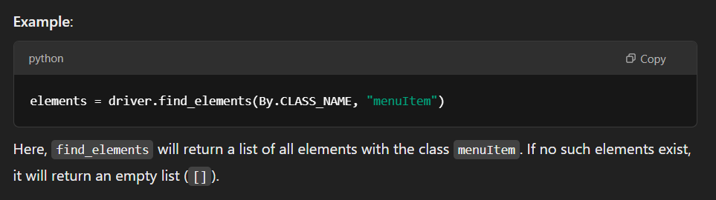
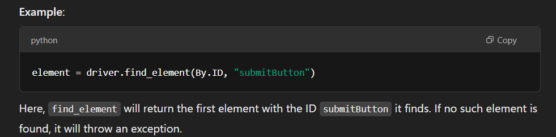

What is Selenium WebDriver, and how is it different from Selenium RC (Remote Control)?
Selenium WebDriver interacts directly with the browser and performs actions faster than Selenium RC, which requires a server component for communication. WebDriver is much simpler and more efficient compared to RC.

What are the different locator strategies in Selenium, and when would you use each one?
• ID:
- Usage: Used to find elements with a unique identifier (ID) on the page.
- Why use it: It is usually the most reliable and fast method as IDs are expected to be unique on a page.
- Example: driver.find_element(By.ID, "username")
• Name:
- Usage: Finds elements by their name attribute.
- Why use it: It can be useful when IDs are not available, but elements have unique name attributes.
- Example: driver.find_element(By.NAME, "q")
• Class Name:
- Usage: Finds elements by their class attribute.
- Why use it: Useful when elements share a class but can also be used when classes are unique to elements.
- Example: driver.find_element(By.CLASS_NAME, "search-input")
• Tag Name:
- Usage: Finds elements by their HTML tag name (like div, button, a, etc.).
- Why use it: Suitable for selecting groups of elements of the same type.
- Example: driver.find_element(By.TAG_NAME, "button")
• Link Text:
- Usage: Finds links by the text inside the anchor (<a>) tag.
- Why use it: Ideal for finding specific links.
- Example: driver.find_element(By.LINK_TEXT, "Sign Up")
• Partial Link Text:
- Usage: Finds links with a partial match to the link text.
- Why use it: Useful when you don't know the exact link text but have a portion of it.
- Example: driver.find_element(By.PARTIAL_LINK_TEXT, "Sign")
• CSS Selector:
- Usage: Finds elements using CSS selectors (can select by class, id, attributes, etc.).
- Why use it: Very flexible and powerful; allows for complex querying based on attributes.
- Example: driver.find_element(By.CSS_SELECTOR, ".btn.submit")
• XPath:
- Usage: Finds elements using an XPath expression, which can navigate through the HTML structure.
- Why use it: Very powerful, allows selection based on conditions, attributes, and element relationships.
- Example: driver.find_element(By.XPATH, "//button[text()='Submit']")

What is the difference between driver.get() and driver.navigate().to() in Selenium, and when would you use each one?
- driver.get(url):
  - This is the most commonly used method in Selenium for loading a page in the current browser window/tab.
  - It is a simple way to load a webpage by providing the URL.
  - It replaces the current page with the new URL.
  - Example: driver.get("https://www.example.com")
- driver.navigate().to(url):
  - This method is very similar to driver.get(url), but it’s part of the Navigate interface in Selenium, which is a bit more advanced.
  - navigate().to() allows for more control over the browser's navigation, which includes going forward, backward, and refreshing the page.
  - Navigating between tabs: Although navigate().to() can also open a new URL in the current window, when you are working with multiple tabs, you can switch between them and use navigate().to() to move between URLs.
  - Example: driver.navigate().to("https://www.example.com")
Key Differences:
- driver.get() is a simpler and direct way to load a URL.
- driver.navigate().to() is part of a broader navigation interface, useful when you want to control browser navigation (e.g., forward, back, refresh), and also has the flexibility to navigate to a new URL in the same session.

What is the purpose of the ActionChains class in Selenium, and can you give an example of how to use it for mouse actions like hovering over an element and clicking on it?
You’re right! The ActionChains class in Selenium is used to perform complex user interactions, such as:
- Hovering over an element.
- Dragging and dropping elements.
- Clicking on elements after hovering.
- Right-clicking (context-clicking).
- Double-clicking.
- Keyboard actions like pressing keys.
You’re spot on mentioning drag and drop operations and moving elements. Let's go into more detail on how you can use ActionChains for such operations.
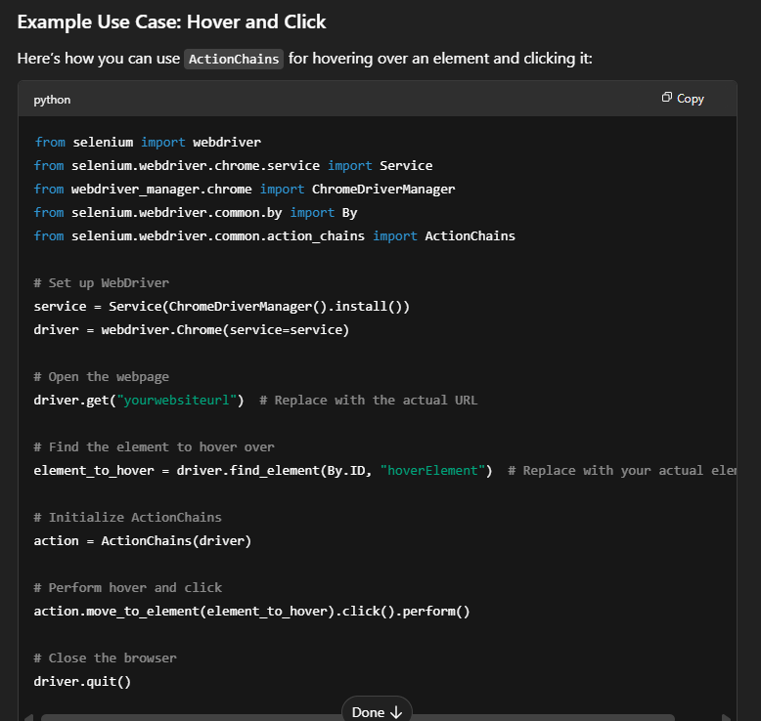
Key Functions of ActionChains:
- move_to_element(): Moves the mouse to the element you specify (like hovering over a menu).
- click(): Clicks on the element after the mouse hovers over it.
- perform(): Executes the sequence of actions.
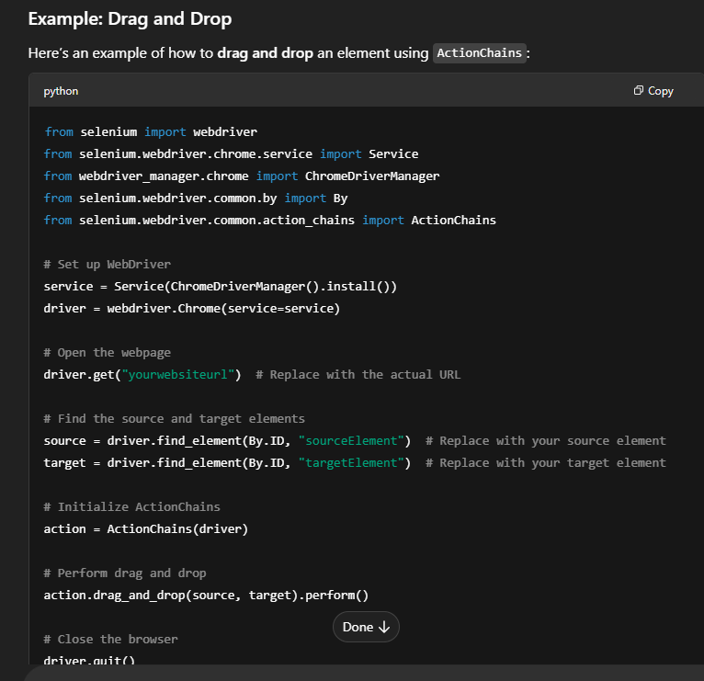
Summary:
- ActionChains provides methods to perform mouse-related actions like hovering, clicking, dragging, etc.
- move_to_element(), click(), drag_and_drop(), and others are part of the chain of actions you can define and then execute with perform().

Write a Python Selenium script that performs the following- for dropdown:
- Navigate to a page with a dropdown.
- Select an option from the dropdown by visible text (e.g., "Option 2").
- Print the selected option to confirm it's selected.
The Select class in Selenium is specifically designed to handle dropdown operations. You can use it to select options by visible text, index, or value. After selecting an option, you can retrieve the selected option to confirm that it was selected.
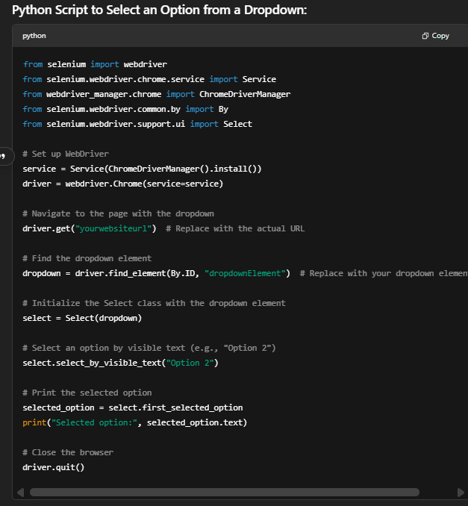
Key Concepts:
- Select class: Used to interact with <select> dropdown elements.
- select_by_visible_text(): Selects an option based on the visible text.
- first_selected_option: Retrieves the currently selected option.
Other Methods of Select:
- select_by_index(index): Selects an option by its index (0-based).
- select_by_value(value): Selects an option by its value attribute.
Python Script to Get Multiple Selected Options:
To get the multiple selected options from a dropdown, you can use the all_selected_options method from the Select class. This method returns a list of all the selected options in the dropdown.
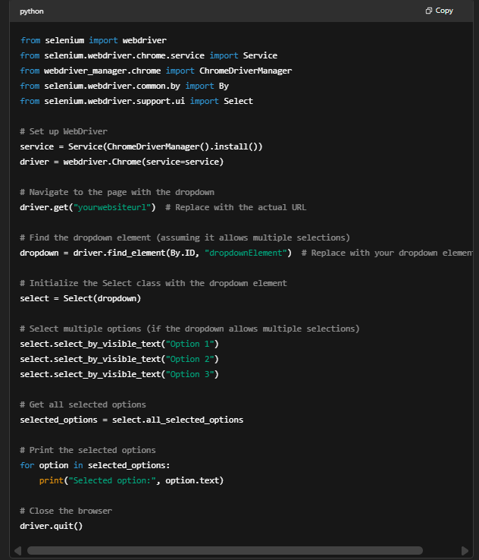
Key Steps:
- all_selected_options: Returns a list of all selected options in the dropdown.
- Loop through the selected options: You can use a loop to print the text of each selected option.

Write a Python Selenium script that uploads a file to a webpage.
To upload a file in Selenium, the general approach is:
- Click the upload button (if it’s a button that triggers a file input dialog).
- Locate the file input element (the <input type="file"> field).
- Use send_keys() to send the file path to the input field
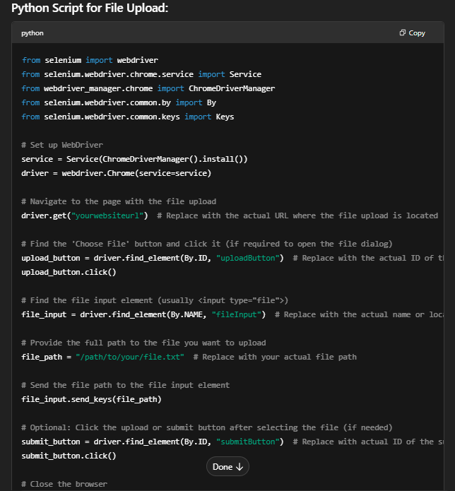
Key Points:
- send_keys() is used to send the file path directly to the file input field (the <input type="file"> element).
- upload_button.click(): This is only required if there’s a button that needs to be clicked to open the file upload dialog.
- File Path: Ensure the file path is correct and points to the file you want to upload.

Python Q&A

What is the difference btw pop and remove.
In Python, both pop() and remove() are used to delete elements from a list, but they work differently:
- pop(index): Removes an element based on its index and returns the removed value.
- remove(value): Removes the first occurrence of the specified value from the list but does not return anything.

What is the difference between a module and a package?
- A module is a single Python file (.py) that contains Python code, such as functions and classes.
- A package is a collection of multiple modules organized in a directory with an __init__.py file, allowing structured and reusable code.
Example:
- Module: math.py (a file containing mathematical functions)
- Package: numpy (a folder containing multiple modules like numpy.linalg, numpy.random, etc.)

Is Python a compiled language or an interpreted language?
Python is an interpreted language, meaning that code is executed line by line at runtime by the Python interpreter. However, Python first compiles the code into bytecode (.pyc files) before interpreting it, making it a mix of both but primarily interpreted.

What are the benefits of using Python language as a tool in the present scenario?
- Easy to Learn & Use: Simple syntax similar to English.
- Cross-Platform: Works on Windows, macOS, and Linux.
- Huge Libraries & Frameworks: Supports AI, ML, data science, web development, etc.
- Strong Community Support: A large community for help and development.
- Automation & Scripting: Great for automating repetitive tasks.

What are global, protected, and private attributes in Python?
- Global Attributes: Defined outside a class and can be accessed anywhere in the program.
- Protected Attributes (_var): Can be accessed within the class and subclasses but should not be used outside.
- Private Attributes (__var): Only accessible inside the class and not directly outside.
Example:
class Example:
public_var = "I am public"
_protected_var = "I am protected"
__private_var = "I am private"

Is Python case-sensitive?
Yes, Python is case-sensitive. Variables, functions, and class names distinguish between uppercase and lowercase letters.
Example:
name = "Alice"
Name = "Bob"
print(name) # Outputs: Alice
print(Name) # Outputs: Bob
Here, name and Name are different variables.

What is Pandas?
Pandas is a powerful Python library for data analysis and manipulation. It provides two main data structures:
- Series (1D data)
- DataFrame (2D tabular data)
Example:
import pandas as pd
data = pd.DataFrame({"Name": ["Alice", "Bob"], "Age": [25, 30]})
print(data)

How is Exception handling done in Python?
Exception handling in Python is done using try-except blocks to handle runtime errors and prevent program crashes.
Example:
try:
x = 10 / 0 # Division by zero error
except ZeroDivisionError:
print("Cannot divide by zero!")

What is the Difference between for loop and while loop in Python?
- For loop: Used when the number of iterations is known.
- While loop: Used when the number of iterations is unknown and depends on a condition.
Example:
# For loop
for i in range(3):
print(i) # Outputs 0, 1, 2

# While loop
x = 0
while x < 3:
print(x) # Outputs 0, 1, 2
x += 1

Is Indentation Required in Python?
Yes, indentation is required in Python to define blocks of code. Unlike other languages that use braces {}, Python uses indentation to structure the code.
Example:
if True:
print("Indented correctly") # Correct
# print("This will cause an error") # Incorrect (no indentation)

What is the use of self in Python?
self refers to the instance of the class and is used to access variables and methods inside a class. It must be explicitly defined as the first parameter in instance methods.
Example:
class Person:
def __init__(self, name):
self.name = name # 'self.name' refers to the instance attribute

def greet(self):
print(f"Hello, my name is {self.name}")

p = Person("Alice")
p.greet() # Outputs: Hello, my name is Alice

Difference btw sort and sorted
1. sort() (In-Place Sorting)
- Works only on lists.
- Modifies the original list in place (does not return a new list).
- Returns None.
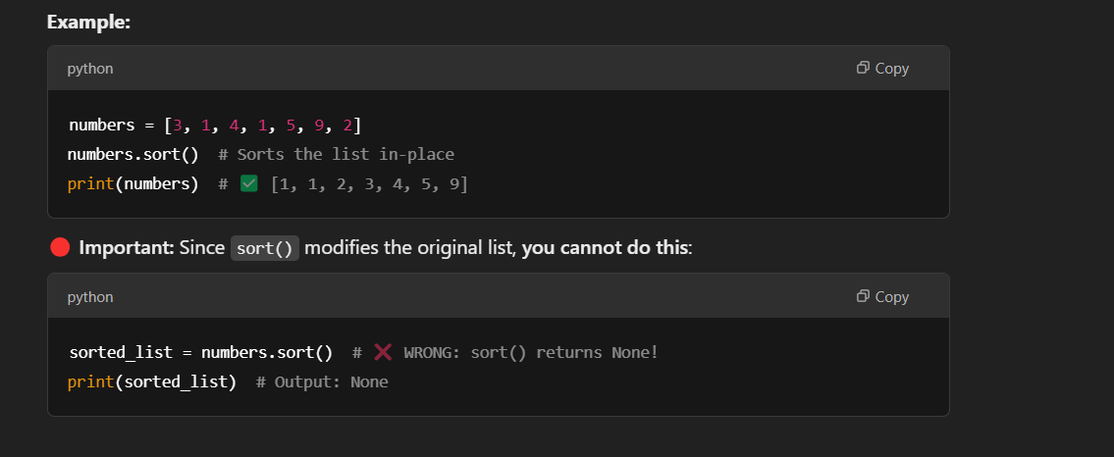
2. sorted() (Returns a New Sorted List)
- Works on any iterable (lists, tuples, strings, dictionaries, etc.).
- Returns a new sorted list (does not modify the original).
- Can be used on immutable data types like tuples.
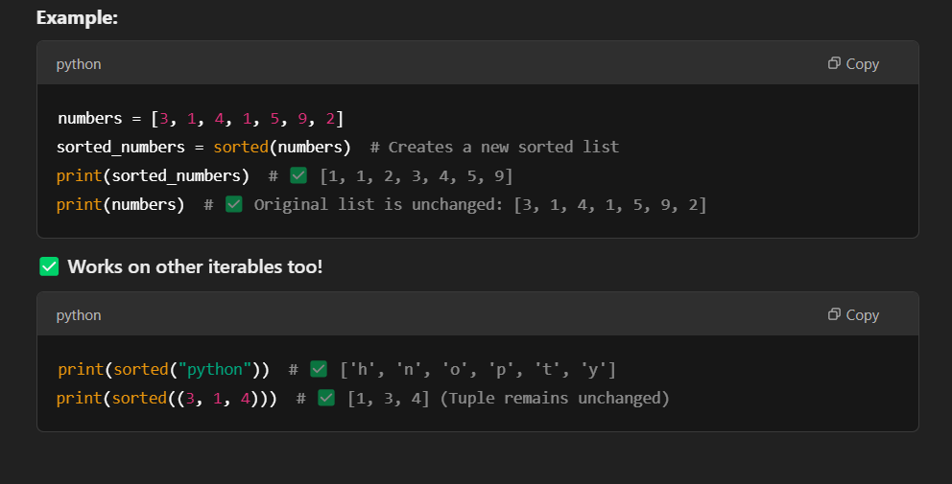
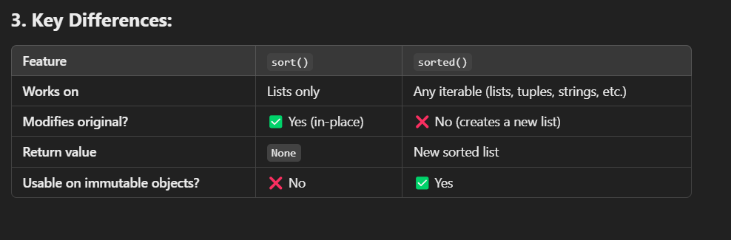

Difference Between Shallow Copy and Deep Copy in Python
When copying objects in Python, you can create either a shallow copy or a deep copy. The key difference lies in how the copies handle nested objects (lists, dictionaries, or objects inside other objects).
1. Shallow Copy
A shallow copy creates a new object, but it only copies references to the nested objects instead of duplicating them. This means changes in the copied object's nested elements will affect the original.
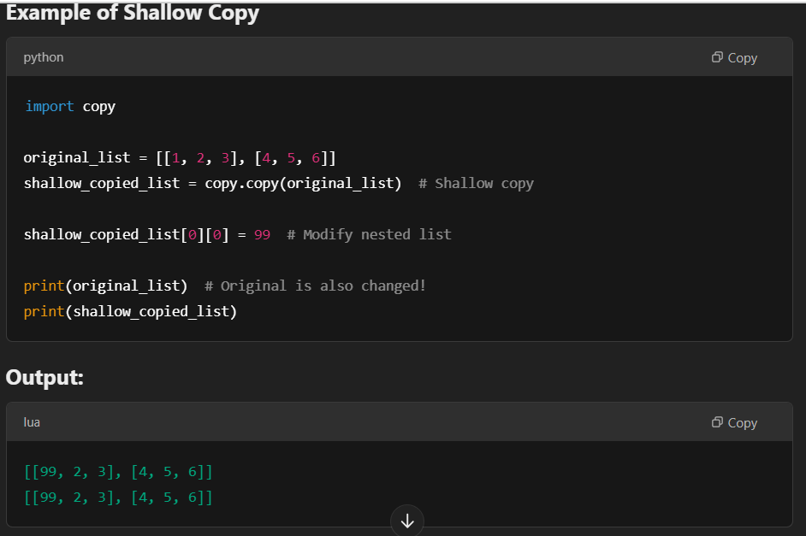
2. Deep Copy
A deep copy creates a new object and recursively copies all nested objects. This ensures that modifications in the copied object do not affect the original.
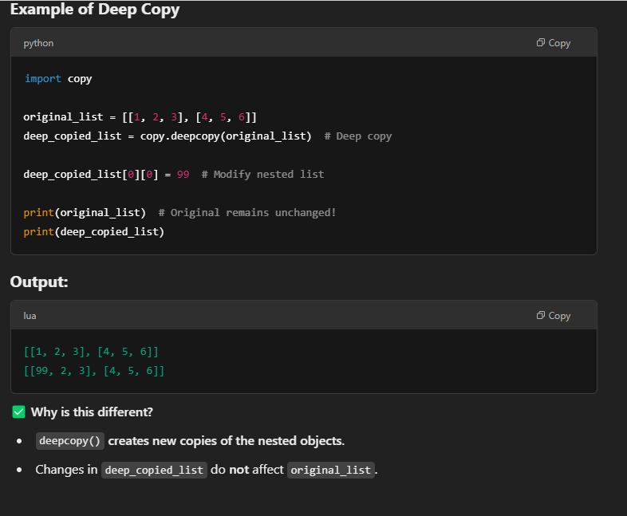
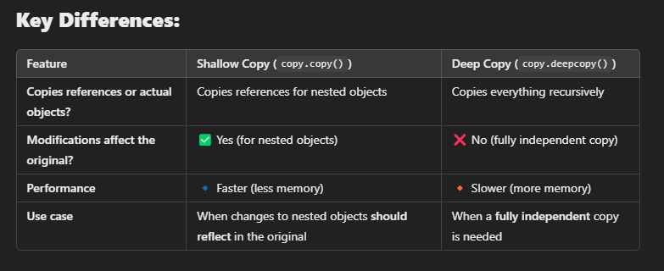

Explain the difference between is and == in Python. When should each be used?
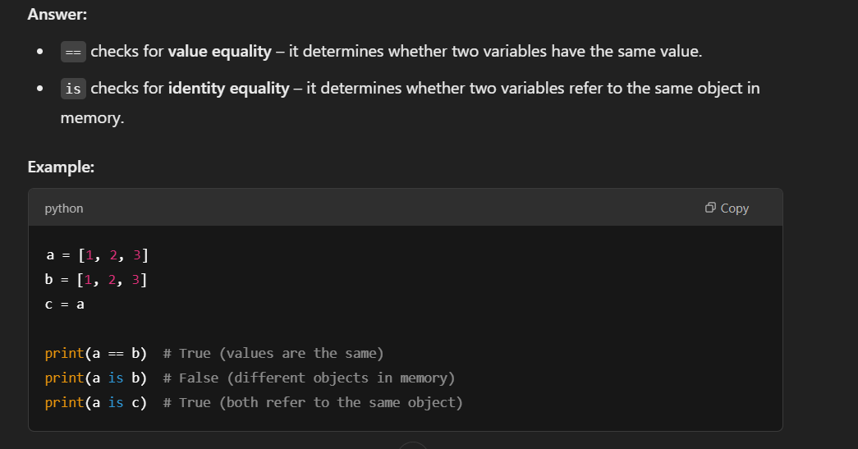
When to use which?
- Use == when you want to compare values.
- Use is when you want to check if two variables point to the same object in memory (e.g., when checking None, use if x is None:).

What are Python’s staticmethod and classmethod? How do they differ?
Key Differences:
- @staticmethod
  - Does not take self or cls as a parameter.
  - It behaves just like a regular function but belongs to the class namespace.
  - It cannot modify class or instance attributes.
- @classmethod
  - Takes cls as a parameter, which represents the class itself.
  - It can modify class-level attributes and share changes across all instances.
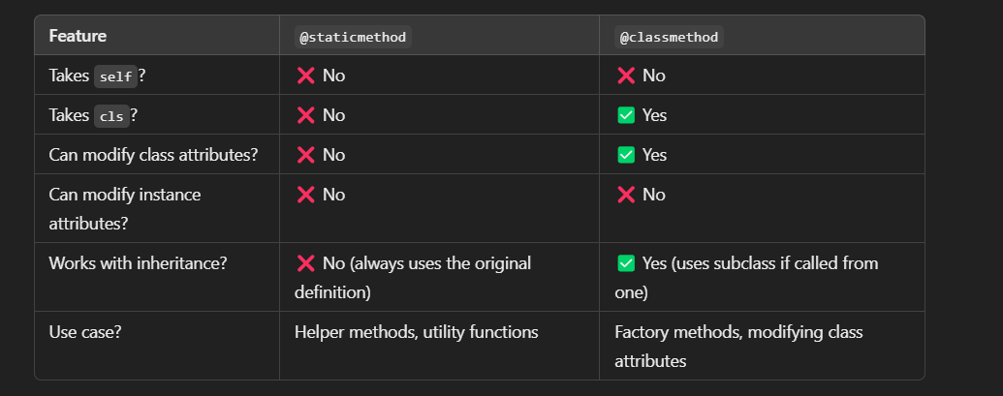

DevOps

Tools

General QA

How do you handle a situation where a critical bug is found just before release?
- Assess Severity: First, assess the severity and impact of the bug. If it's critical, it could be a blocker for the release.
- Communicate: Immediately notify the relevant stakeholders (product owner, developers, project manager) about the issue.
- Prioritize Fix: Work closely with the development team to prioritize fixing the bug.
- Test the Fix: Once the bug is fixed, quickly validate the fix and perform regression testing to ensure it hasn't impacted other areas.
- Release Decision: Depending on the fix, decide whether to delay the release or push out a hotfix post-release.
- Documentation: Ensure proper documentation of the issue for future reference.

What is risk-based testing, and how do you apply it in real-world scenarios?
- Risk-Based Testing: It involves prioritizing test cases based on the potential risk of failure in different components of the application. High-risk areas, such as those with complex code or high user traffic, should be tested first.
- Real-World Application: For instance, in an e-commerce application, critical functionalities like checkout and payment processing would be considered high risk. As a result, these areas would be tested with higher priority compared to less critical features like user profile management.

What is the role of a QA engineer in an Agile development environment?
- Continuous Involvement: A QA engineer in Agile is involved from the start of the sprint. They collaborate with developers, product owners, and other stakeholders to clarify requirements and ensure quality from day one.
- Test Automation: They may automate regression tests and work on maintaining the test suite as the application evolves.
- Continuous Feedback: They provide feedback during daily stand-ups and sprint reviews, ensuring that any quality issues are addressed promptly.

What is the purpose of a test plan, and what key elements should it contain?
A test plan is a document that outlines the scope, approach, resources, and schedule for testing activities. It ensures that all stakeholders are aligned. Key elements include:
- Test Objectives: What you are testing and why.
- Scope: Features and functions to be tested and not tested.
- Test Strategy: Testing approach (manual, automated, performance, etc.)
- Resources and Roles: Testers, tools, and environments.
- Test Schedule: Timeline for testing activities.
- Risk Assessment: Any potential risks and mitigation strategies.

What are some common challenges you face as a QA engineer, and how do you overcome them?
Some common challenges include:
- Lack of clear requirements: This can be mitigated by collaborating with business analysts and product owners early in the project to clarify requirements.
- Time Constraints: In Agile environments, there may be limited time for testing. Test automation can help mitigate this by enabling faster feedback.
- Changing Requirements: Agile projects often see frequent requirement changes. A flexible approach and continuous testing throughout the sprint can help accommodate these changes.
- Environmental Issues: Inconsistent test environments can cause unreliable results. Automating environment setup and using containerized environments (like Docker) can improve consistency.

You mentioned leading end-to-end software testing in the IRD and OMD projects. Can you walk me through your role in these projects, particularly how you aligned testing with the overall development lifecycle?
In end-to-end testing, I actively participated across all phases of the Software Testing Life Cycle (STLC)—from test planning, case design, and execution to defect tracking and closure. For example:
- In test planning, I collaborated with stakeholders to define test scope, timelines, and deliverables.
- During test design, I created both manual and automated test cases (using Python/Selenium) to cover functional, API, and UI scenarios.
- In execution, I ran regression, integration, and system tests, ensuring alignment with Agile sprints.
- For defect management, I logged issues in JIRA, prioritized them with dev teams, and retested fixes.
- Finally, in test closure, I prepared reports with metrics (e.g., pass/fail rates, defect density) to share with stakeholders.
This end-to-end involvement ensured quality gates were met at each stage and accelerated release cycles."

You ensured compliance with quality standards across the STLC. Can you break down the key phases of STLC you worked on and explain how you contributed to each phase—especially in test planning, case design, and defect management?
"Yes, I’ve contributed to all phases of the STLC, ensuring alignment with both client requirements and development workflows. Here’s how I approached each phase:
- Test Planning:
  - Analyzed client requirements and BRDs (Business Requirement Documents) to define test scope, timelines, and deliverables.
  - Collaborated with PMs and devs to prioritize test scenarios based on risk (e.g., high-traffic API endpoints).
  - Tools: Confluence for documentation, JIRA for tracking.
- Test Design:
  - Developed manual and automated test cases (using Python + Pytest/Selenium) mapped to user stories.
  - Incorporated boundary value analysis and positive/negative testing for robustness.
  - Conducted peer reviews with devs to ensure coverage gaps were addressed early.
- Test Execution:
  - Ran regression, integration, and system tests in Agile sprints, with 80%+ automation coverage for repetitive scenarios.
  - Flagged critical defects (e.g., streaming latency in the IRD project) and tracked SLA compliance for fixes.
- Defect Management:
  - Logged defects in JIRA with clear steps-to-reproduce, screenshots, and severity labels (P0-P3).
  - Worked closely with devs to reproduce issues and validate fixes in staging environments.
- Test Closure:
  - Prepared test summary reports with metrics (pass/fail rates, defect leakage) for stakeholders.
  - Conducted retrospectives to improve processes (e.g., reducing flaky tests in CI/CD pipelines).

You mentioned automating tests with Selenium and Pytest. Can you walk me through your test framework architecture? How did you handle challenges like dynamic XPaths or test flakiness?
For our test framework, we used a Python + Pytest + Selenium stack with a Page Object Model (POM) design pattern to promote reusability and maintainability. Here's how we addressed key challenges:
- Dynamic Elements:
  - Used relative XPaths (e.g., //button[contains(@class, 'submit-btn')]) over absolute paths to resist UI changes.
  - Implemented explicit waits (WebDriverWait + expected_conditions) to handle async loads, avoiding time.sleep().
  - For complex scenarios (e.g., SVG elements), leveraged CSS selectors or JavaScript execution via execute_script().
- Flakiness Mitigation:
  - Retry Mechanism: Decorated flaky tests with @pytest.mark.xfail or pytest-rerunfailures (e.g., @pytest.mark.flaky(reruns=2)).
  - Pre-Check Validation: Added sanity checks (e.g., verifying API responses via requests before UI steps).
  - Parallel Execution: Used pytest-xdist to isolate tests and reduce environment collisions.
- Framework Enhancements:
  - Custom Reporters: Integrated Allure Reports for granular failure analysis (screenshots, DOM snapshots).
  - CI/CD Integration: Hooked the framework into Jenkins pipelines with Dockerized browsers for consistency.

You mentioned CI/CD integration with Docker and Jenkins. How did you ensure your automated tests were reliable in the pipeline? What metrics did you monitor to improve stability?
"We designed a Jenkins-based CI/CD pipeline with Docker to ensure end-to-end automation from code deployment to test reporting. Here’s the workflow and how we ensured reliability:
- Pipeline Architecture:
  - Dockerized Testing: Containerized browsers (Chrome/Firefox) for environment consistency.
  - Stages:
    - Code checkout → Build (Docker image) → Deploy (staging) → Automated Test Execution (Pytest/Selenium).
    - Post-Build: Allure report generation + Slack/email notifications.
- Stability Measures:
  - Flaky Test Handling: Used pytest-rerunfailures for transient issues.
  - Pre-Pipeline Checks:
    - API Health Checks: Verified backend services before UI tests.
    - Resource Monitoring: Ensured Docker containers had adequate CPU/memory.
  - Failure Analysis: Allure’s screenshots, logs, and video recordings (via Selenium Grid) for root cause analysis.
- Metrics & Accountability:
  - Tracked build pass/fail rates, test flakiness %, and defect escape rate.
  - Triage Process:
    - If failures were test-side (e.g., locator changes), we fixed them in the automation suite.
    - If dev-side (e.g., API breaking changes), we filed JIRA tickets with repro steps and severity labels (P0-P2).

You mentioned tracking metrics like defect escape rate. How did you use these metrics to improve QA processes? Can you share an example where data drove a strategic change?
"We leveraged JIRA not just for defect tracking, but as a centralized hub for end-to-end test management. Here’s how we ensured transparency and data-driven decisions:
- Defect Tracking:
  - Logged defects with detailed repro steps, screenshots, and environment logs to accelerate triage.
  - Used priority/severity labels (P0-P3) and SLA-based workflows to align fixes with release timelines.
- Test Coverage Visibility:
  - Mapped test cases to JIRA issues (epics/stories) to track coverage gaps in real time.
  - Generated traceability matrices to prove all requirements had corresponding tests.
  - Monitored ‘% Covered’ metrics (e.g., ‘85% of sprint user stories tested’) to identify backlog risks early.
- Strategic Improvements:
  - Example: Noticed a recurring 20% gap in edge-case testing for API endpoints. Proposed and implemented:
    - Automated boundary testing (Pytest + parameterized tests).
    - Peer reviews of test cases during sprint planning.
  - Outcome: Reduced defect leakage to production by 25% in subsequent releases.
- JIRA Integrations:
  - Synced with Confluence for living documentation.
  - Used JIRA dashboards to share sprint/test metrics with leadership (e.g., pass rate, defect trendlines).

You mentioned improving CI/CD reliability. Walk me through a specific challenge you faced in the pipeline, how you debugged it, and the impact of your solution.
"In the OMD project (Challenge), manual deployments took 24+ hours due to inconsistent environments and post-deploy smoke testing. To solve this:
- Action:
  - Integrated a Jenkins pipeline with Dockerized environments (Chrome/Firefox containers).
  - Automated end-to-end deployment + testing (build → deploy → smoke tests → regression).
  - Added failure-handling logic:
    - Environment flakes: Auto-retry failed stages (max 3x).
    - Build issues: Escalated to devs via JIRA tickets with logs, screenshots, and suggested workarounds.
- Result:
  - Cut deployment time from 1 day to 2.5 hours (88% faster).
  - Reduced pipeline failures by 70% through proactive debugging.
  - Devs adopted the same Docker setup locally, slashing ‘works on my machine’ issues."*

Why This Works:
✅ CAR Structure: Clear problem → solution → outcome.
✅ Metrics: Time savings (88%), failure reduction (70%).
✅ Leadership: Shows cross-team impact (devs using Docker).
1 Tweak to Elevate Further:
- Add a specific example of a bug caught/fixed this way.
  - "For instance, a memory leak in the IRD decoder only appeared in Docker. We caught it pre-prod and fixed it within the sprint."

Question 2: Debugging Pipeline Failures
"You mentioned auto-retrying flaky stages. How did you determine whether a failure was due to the environment vs. a genuine bug? Walk me through your analysis."
Tips:
- Mention tools/logs (e.g., Docker logs, Selenium screenshots).
- Highlight collaboration (e.g., "worked with DevOps to monitor RAM/CPU").
- Quantify time saved (e.g., "cut debug time from 3 hours to 30 mins").
(Reply with your answer, and I’ll refine it next!)

Example:
*"I used a 3-step verification:
- Logs: Checked Docker/container logs for OOM errors.
- Artifacts: Reviewed Allure reports for UI element staleness.
- Isolation: Re-ran failed tests locally in a clean container.
This revealed 80% of ‘failures’ were environment timeouts, not bugs. We then added resource monitoring to Jenkins nodes."*

How did you keep non-technical stakeholders (e.g., Product Managers) informed about pipeline health and risks?
"To keep stakeholders aligned, I bridge the gap between technical metrics and business impact through visual storytelling and proactive updates:
- Real-Time Visibility:
  - Dashboards: Shared live Grafana/Allure dashboards with traffic-light indicators (Green/Amber/Red) for:
    - Release Readiness (% tests passed, critical bugs).
    - Pipeline Health (deployment time trendlines, flakiness %).
  - Example: During the OMD launch, a ‘Red’ dashboard alert on payment API failures let PMs delay a feature flag until we fixed it.
- Tailored Updates:
  - Emails/1-Pagers: Sent weekly summaries with:
    - Plain-language risks (e.g., "Login tests failing → 20% user impact risk").
    - Screenshots of key graphs (no raw data).
  - Example: Used a side-by-side comparison of test coverage (85% → 92%) to justify extending a sprint.
- Preemptive Syncs:
  - Held 15-minute ‘risk huddles’ pre-release with PMs/Devs to:
    - Translate pipeline failures into user impact (e.g., "Docker crashes → 10% slower video loads").
    - Agree on actionable next steps (e.g., rollback, hotfix).

Flow of over framework
